## The Lines Properties

The properties of the **Lines** are defined by setting the style of stroke used:

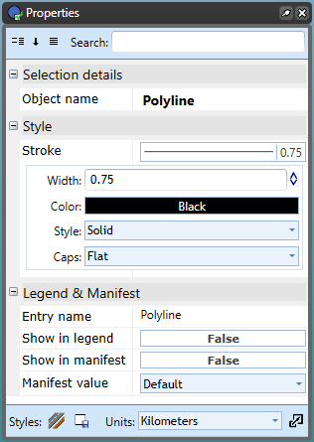

Polyline_Properties_Palette

| Properties |  |
| --- | --- |
| **Stroke width** | The weight of the line (default is 0.75). |
| **Stroke color** | The color of the line. |
| **Stroke style** | A variety of dashed, solid and dotted line styles are available. |
| **Stroke caps** | Choose from four line end styles: flat, square, round, and triangle. |

:::